Type proxy setting on screen search

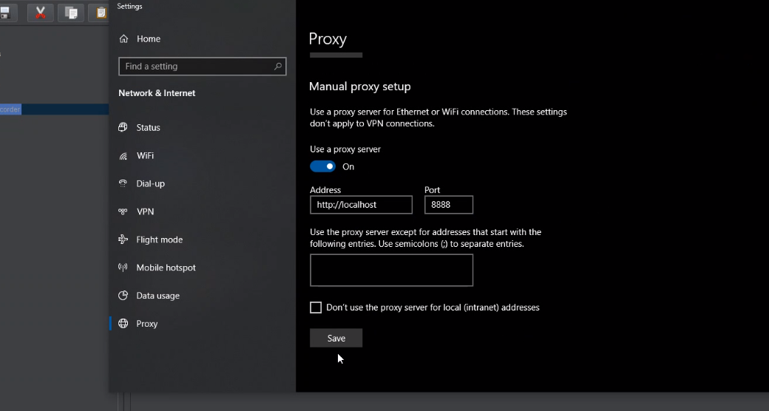

Thentype certificat on windows searchl
Go to manage certificate
Click trusted root certification authorities

I think add certificate and then add up to apache bin with the certificate and it adds it or so.

